**Part A - Multiple Choice Questions (10 Marks)**

|  |  |  |
| --- | --- | --- |
| **1** |  | **C** |
| **2** |  | **A** |
| **3** |  | **B** |
| **4** |  | **D** |
| **5** |  | **C** |
| **6** |  | **A** |
| **7** |  | **C** |
| **8** |  | **D** |
| **9** |  | **A** |
| **10** |  | **D** |

1. Which of the following statements is **NOT** true about mitosis?

a) Mitosis results in the formation of 2 daughter cells identical to the parent cell.

b) Takes place all over the body.

c) Involves the use of RNA in the duplication of chromosomes.

d) Is used for growth and repair of the body cells.

1. Artificial hormone pills have been helpful when given to some people who have been

unable to have children; however, the dosage of these pills has to be carefully regulated

because an over-dose can cause multiple births. This implies that the effect of the hormone

is to:

a) stimulate ovulation in the woman.

b) stimulate sperm production in the man.

c) ensure that the embryos remain fixed in the uterus.

d) increase sexual desire.

1. The greatest chance for an ovum to be fertilised, is having sexual intercourse:
2. at the beginning of the menstrual flow.
3. two weeks after menstruation starts.
4. at the end of the menstrual flow.
5. at the end of the menstrual cycle.

1. In meiosis, the chromosome number is halved in order to:

a) ensure the DNA is copied completely.

b) maintain all the DNA in the daughter cells.

c) ensure that errors in crossing-over can be corrected at fertilisation.

d) maintain the correct chromosome number in offspring.

1. The main purpose of the fluid produced by the seminal vesicle is to:
2. lubricate the urethra.
3. help activate the sperm.
4. provide sugar for the sperm for energy.
5. cause the final maturation of the spermatozoa.
6. Which of the following is NOT correct regarding spermatogenesis?
7. It begins before birth then ceases until after puberty.
8. It occurs continually after puberty.
9. The process takes about 72 days.
10. One spermatogonium results in four viable spermatozoa.
11. Proliferation describes the :
12. the differentiation of cells.
13. the specialisation of cells.
14. the rapid division of cells.
15. the growth of cells.
16. The embryo is surrounded by the amniotic cavity, filled with amniotic fluid. This fluid:
17. acts as a shock absorber
18. provides a medium through which the exchange of materials takes place between the mother and embryo
19. helps to regulate a constant temperature
20. produces hormones for the developing embryo
21. i and iv only
22. ii and iii only
23. i and ii only
24. i and iii only
25. Which of the following consists of both maternal and foetal tissue?
26. Placenta.
27. Umbilical cord.
28. Amnion.
29. Foetus.
30. Which of the following substances would be in higher concentration in the umbilical arteries than in the umbilical vein?
31. Glucose.
32. Amino acids.
33. Vitamins.
34. Carbon dioxide.

**Short Answer Section (41 marks)**

Use the following diagram of the male reproductive system to answer question one.

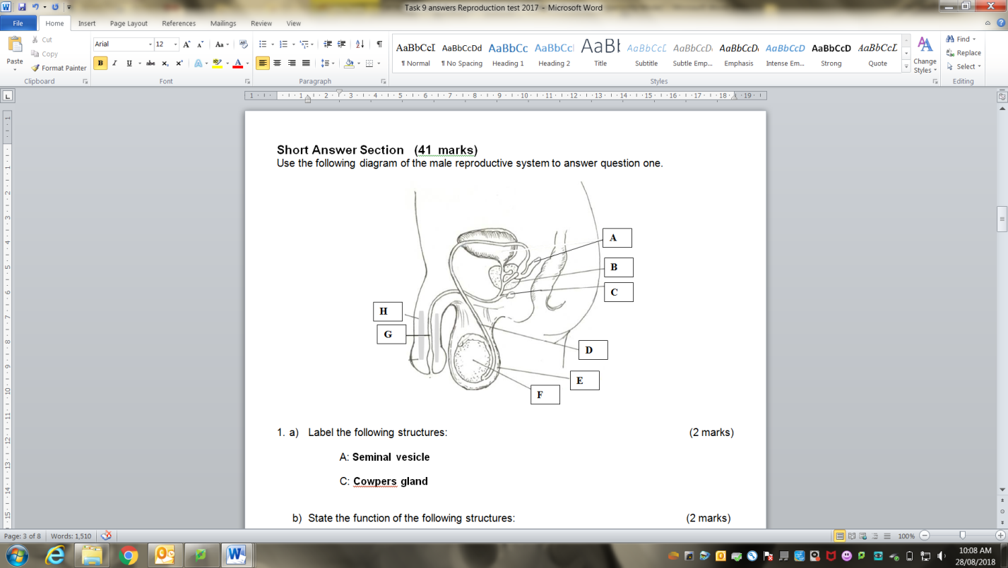

1. a) Label the following structures: (2 marks)

A: **Seminal vesicle**

C: **Cowpers gland / Bulbo-Urethral Gland**

1. State the function of the following structures: (2 marks)

E : **raise and lower testes to keep at 34oC**

G: **passage way for semen and urine**

1. If a male developed prostate cancer and had to have his prostrate removed would he still be able to have children with his partner by natural means? Explain your answer. (3 marks)

*No.*

**Prostrate provide alkaline fluid to protect and activate sperm (1)**

**No protection from acid so acid will kill sperm (1)**

**Sperm not activated as no alkaline to react with acid (1)**

***If answer yes and they have given a logical reasons can also mark.***

Use the diagram of the ovary shown below to answer question 2.

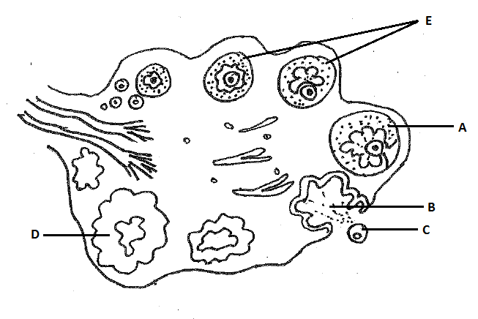

2. a) What role does structure D play in the menstrual cycle? (1 mark)

**Produces progesterone to cause lining to thicken (1)**

b) Describe the hormonal sequence of events that enable “C” to be released from the ovary. (2 marks)

**FSH makes follicle mature and go through meiosis (1) *2 points needed***

**LH is released, causes follicle to swell and burst (1)**

**Bursting releases oocyte out of the ovary (1)**

c) Complete the following table on the major stages of the menstrual cycle. (5 marks)

|  |  |  |
| --- | --- | --- |
| **Stage** | **Time span** | **Events** |
| Menstruation | 1-4 | ***Lining released from the uterus (description)*** |
| Preovulation | 5-12 | Endometrial repair; development of ovarian follicle;  Uterine lining gradually thickens |
| ***ovulation*** | 13-15 | ***Oocyte released from the ovary*** |
| secretion | 16-20 | Secretion of watery mucus by glands of endometrium,  cervix and uterine tubes; |
| ***Post ovulation or premenstruation*** | 21-28 | ***Lining continues to thicken until corpus luteum dies/egg dies*** |

3. Many features of both reproductive systems depend on the endocrine glands for their regulation. The endocrine glands produce many hormones each has a specific target organ and effect.

Complete the following table identifying the hormones specific target organ(s) and its effect(s) in **both** male and females. (3 marks)

|  |  |  |
| --- | --- | --- |
| **Hormone** | **Target organ(s)** | **Effect(s) of hormone** |
| HCG – Human Chorionic Gonadotrophin | ***Ovary*** | ***Causes corpus luteum to stay alive*** |
| Testosterone | ***testes*** | ***Causes maturation of sperm*** |

4. Outline the pathway of a sperm from its release from the epididymis to its ejaculation in semen from the body. Include the major events that occur along the way. (5 marks)

***Travels through vas deferens***

***Fluid rich in sugar is added from the seminal vesicle***

***Passes prostate where alkaline prostate fluid added***

***Enters the urethra***

***Lubricant added from the Cowpers gland***

***Semen leaves the penis via the urethra***

*(Any five points for 1 mark)*

5. Use the table below to complete the summary of mitosis. Name the stages described or outline the key events occurring at each stage named. NOTE: Stages are NOT listed IN ORDER. (5 marks)

|  |  |
| --- | --- |
| Stage | Events |
| ***Telophase (1/2)*** | Nuclear membranes and nucleoli form; chromosomes uncoil and disappear |
| Anaphase | ***Chromosomes pulled to either end by spindle fibres (1)*** |
| ***Cytokinesis (1/2)*** | Cytoplasm of the cell divides into 2, each with a new nucleus. |
| ***Interphase (1/2)*** | DNA molecules replicate |
| Metaphase | ***Chromosomes line up on equator, attach by centromere (1)*** |
| ***Prophase (1/2)*** | ***Nuclear membrane disappears, centrioles appear, spindle fibres form (2 things) (1)*** |

7. Use the diagram below to answer the following questions.

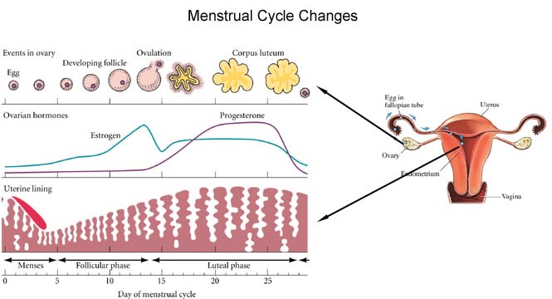

What hormones are represented by the lines on the graph and explain how you came to your conclusion. (3 marks)

***Oestrogen and progesterone (1)***

***One starts when follicle begins to mature and increases – oestrogen (1), other starts when corpus luteum made which makes progesterone (correct descriptions) (1)***

8. Once the zygote has been formed it will go through many changes before being brought into the world

a) Explain what is meant by the term cell differentiation? (1 mark)

***Cell becomes specialised***

b) Give two reasons why the best place for fertilisation of the egg to occur is midway along the fallopian tube. (2 marks)

***only the fittest sperm can swim that far = healthy baby (1)***

***needs enough time to develop into a blastocyst before reaching the uterus (1)***

c) There are three primary germ layers that develop within the blastocyst, give two examples of structures that will be formed by each of the primary germ layers. (3 marks)

Endoderm ***epithelial layers alimentary canal, lungs, bladder etc***

Mesoderm ***bone, muscle, blood, connective tissue etc***

Ectoderm ***nervous system, epidermis of skin, hair, nails etc***

9. Once the blastocyst implants the placenta starts to form and takes about 3 months till it is fully functional. Discuss why an embryo/foetus would need such an organ as the placenta. (4 marks)

***Embryo cannot breathe as lungs full of liquid***

***Placenta enables oxygen from mother’s blood to diffuse into foetal blood and CO2 from foetal to maternal (1)***

***Embryo cannot eat food as in womb***

***Placenta enable nutrients from mother’s blood to pass into foetal blood (1)***

***Embryo cannot get rid of waste***

***Placenta enables waste to diffuse from foetal blood into maternal so it can be removed by mother (1)***

***No placenta there would be no hormones being made to hold the lining in place so it would be shed by the body. (1)***

**EXTENDED ANSWER QUESTION (10 marks)**

1. With the aid of diagrams, discuss the similarities and differences between spermatogenesis and oogenesis.

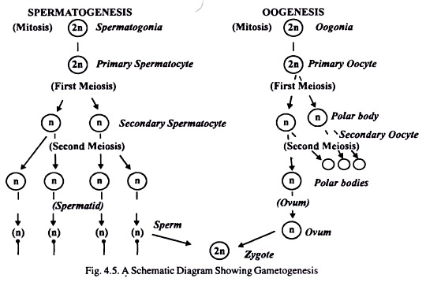

**Ovary**

**puberty**

**Birth**

**puberty**

**Prophase I**

**Metaphase II**

**fertilisation**

**Fallopian tube**

**Spermatozoa**

***1 mark for diagram of spermatogenesis***

***1 marks for correct names on oogenesis***

***1 mark for the correct phases of primary oocyte and secondary oocyte***

***Similarities – 2 marks***

***Both produce gametes with 23 chromosomes***

***Both take place in the primary sex organs***

*Any other suitable answer*

***Differences - 5 marks***

***Spermatogenesis takes place in one place - testes, oogenesis in two – ovary and fallopian (1)***

***Spermatogenesis takes 72 days, oogenesis takes approx. 28 days (1)***

***Spermatogenesis starts at puberty, oogenesis starts before birth and then pauses until puberty (1)***

***Spermatogenesis once started will finish, oogenesis will start but will not finish until fertilisation occurs (1)***

***Mitosis occurs before spermatogenesis starts every time, mitosis occurred before the female was born (1) \*\*****need for maximum marks*

***Spermatogenesis is a lifelong process, oogenesis stops after menopause (1)***

***\*\*****need for maximum marks*